REQUIREMENTS ANALYSIS REPORT
AgriConnect: A Digital Marketplace & Advisory Platform for Agribusiness Stakeholders
Junior Software Developer – Agribusiness Solution Internship
Week 1 Task: Requirements Gathering and Analysis
Prepared by: Akash Srivastav
Internship Platform: YuvaIntern (NSDC)
Date of Submission: 17 September 2026

Table of Contents
1. Introduction
1.1 Background
1.2 Purpose of this Document
1.3 Scope
1.4 Methodology
2. Stakeholder Identification
3. Information Collection: Common Challenges in Agribusiness
4. Requirement Elicitation
4.1 User Personas
4.2 User Stories
4.3 Detailed Use Cases
4.4 Illustrative Scenario
5. Functional Requirements
5.1 User Management
5.2 Crop Listing & Inventory
5.3 Market Price Engine
5.4 Order & Logistics
5.5 Notifications
5.6 Administration & Analytics
6. Non-Functional Requirements
7. System Data-Flow Diagram
8. Use Case Diagram
9. UI Mock-ups
10. Assumptions & Constraints
10.1 Assumptions
10.2 Constraints
11. Requirements Traceability Matrix
12. Conclusion

1. Introduction

1.1 Background
Agriculture remains one of the largest sources of livelihood across many developing economies, yet the value chain connecting producers to end consumers is frequently fragmented, opaque, and inefficient. Farmers often lack real-time access to market prices, buyers struggle to source consistent-quality produce, and intermediaries add cost without adding proportional value. Digital platforms have repeatedly demonstrated the potential to close these gaps by improving information symmetry, enabling more direct transactions between producers and buyers, and delivering data-driven advisory services directly to the field.
This report documents the requirements gathering and analysis phase for “AgriConnect,” a proposed digital agribusiness solution designed to connect farmers and producers, distributors and aggregators, retailers and institutional buyers, logistics partners, and platform administrators on a single platform for crop listing, price discovery, order management, and logistics coordination.

1.2 Purpose of this Document
This document translates the needs of agribusiness stakeholders into a structured set of software requirements that can guide the subsequent design and development phases of the internship project. It captures stakeholder profiles, common industry challenges, representative user stories, detailed use cases, functional and non-functional requirements, and supporting flow diagrams and UI mock-ups, in line with the deliverables specified for the Week 1 task.

1.3 Scope
The scope of this requirements analysis covers the core marketplace and coordination functions of AgriConnect: user registration and profile management, crop and produce listing, market price discovery, order placement and management, logistics and shipment tracking, notifications and alerts, and basic analytics and reporting for administrators. Detailed technical architecture, database schema design, and deployment infrastructure are intentionally out of scope for this document; these will be addressed in the Week 2 System Architecture and Design report, which builds directly on the requirements captured here.

1.4 Methodology
Given the simulated nature of this internship task, stakeholder needs and sector challenges were identified through secondary research using publicly available agriculture-sector reports, government market (mandi) price portals, and commonly documented patterns across existing agritech platforms, combined with reasoned assumptions about a representative agribusiness use case. Requirements were then elicited using standard techniques — persona development, user story writing, and use case modelling — and organised into a functional and non-functional requirements catalogue suitable for design hand-off.

2. Stakeholder Identification
A representative agribusiness scenario involves several distinct stakeholder groups, each with different goals, technical comfort levels, and pain points. The table below summarises the primary stakeholders considered for AgriConnect, their core needs, and the challenges they currently face without a unified digital platform.
Stakeholder | Description | Key Needs | Key Pain Points
Farmers / Producers | Individual or smallholder farmers who grow and sell crops directly or through aggregators. | Fair price discovery, direct market access, simple listing tools, timely payment. | Information asymmetry, exploitation by middlemen, low digital literacy, unreliable connectivity.
Distributors / Aggregators | Entities that purchase produce in bulk from multiple farmers and supply it to retailers or processors. | Reliable supply visibility, quality assurance, bulk ordering tools, logistics coordination. | Inconsistent supply, quality variability, fragmented sourcing, high coordination overhead.
Retailers / Institutional Buyers | Grocery retailers, restaurants, processing units, or institutional buyers purchasing produce for resale or use. | Predictable sourcing, quality transparency, competitive pricing, delivery reliability. | Supply uncertainty, price volatility, limited traceability of origin and quality.
Logistics Partners | Transport and cold-chain providers who move produce from farm gate to market or warehouse. | Clear pickup/delivery schedules, route optimisation, real-time order visibility. | Poor last-mile connectivity, inefficient route planning, spoilage caused by delays.
Platform Administrators | Operators responsible for platform governance, user verification, dispute resolution, and monitoring. | Oversight tools, analytics dashboards, streamlined user and content management. | Fraud and misuse risk, inconsistent data quality, scaling support operations.
Government & Regulatory Bodies | Agencies that publish mandi/market prices, set quality and grading standards, and issue agricultural advisories. | Data interoperability with private platforms, visibility into market activity. | Limited digital integration between government systems and private agritech platforms.
Financial Institutions / Payment Providers | Banks, NBFCs, and payment gateways that facilitate transactions and, potentially, credit to farmers. | Secure system integration, transparent transaction records. | Limited formal credit history and documentation for smallholder farmers.

3. Information Collection: Common Challenges in Agribusiness
Before defining requirements, it is important to understand the structural challenges that a digital agribusiness solution should address. Based on secondary research into the agriculture value chain and patterns observed in existing agritech initiatives, the following challenges were identified as consistently affecting producers, distributors, and buyers in the sector.
- Price Information Asymmetry: Farmers often lack real-time access to mandi/market prices, which leads to distress selling to intermediaries at below-fair value.
- Fragmented, Multi-Tier Supply Chains: Produce typically passes through several intermediaries, each adding margin without adding proportional value, reducing the farmer's share of the final price.
- Post-Harvest Losses: Inadequate storage, cold-chain, and transport infrastructure causes significant spoilage between harvest and final sale.
- Limited Access to Credit & Insurance: Smallholder farmers frequently lack the formal documentation or credit history needed for institutional lending or crop insurance.
- Logistics & Last-Mile Connectivity: Rural areas often face poor road infrastructure and limited transport availability, especially during peak harvest windows.
- Low Digital Literacy & Device Access: Variable smartphone penetration and comfort with digital tools among farmers requires simple, low-bandwidth-friendly interfaces.
- Unreliable Rural Internet Connectivity: Intermittent network coverage requires offline-tolerant or lightweight application design rather than a purely online experience.
- Quality Standardisation & Grading: The lack of consistent grading standards makes it difficult for remote buyers to trust produce quality without physical inspection.
- Delayed & Opaque Payments: Cash-based, delayed settlement discourages trust between parties; digital payment adoption is growing but not yet universal.
- Climate & Advisory Gaps: Farmers often lack timely weather forecasts and crop advisory information needed to plan planting, irrigation, and harvest activities.
These challenges directly informed the requirement elicitation process described in Section 4, ensuring that the resulting functional and non-functional requirements address root causes rather than surface symptoms.

4. Requirement Elicitation

4.1 User Personas
To ground the requirements in realistic behaviour, four representative personas were developed, one for each primary user role. These personas were used throughout the elicitation process to sanity-check user stories and use cases.
Ramesh (42) – Farmer, Nashik district: Grows tomatoes and onions on a 3-acre plot. Owns an entry-level Android smartphone with intermittent 3G/4G connectivity. Goal: get a fair price without travelling to the mandi. Frustration: relies on a local trader for price information and often feels he is under-paid.
Sunita (35) – Distributor / Aggregator, Pune: Runs a small aggregation business sourcing vegetables from 20+ farmers for supply to city retailers. Goal: source consistent volume and quality with minimum coordination effort. Frustration: spends hours daily on phone calls confirming availability and prices.
Arjun (29) – Retailer, Mumbai: Owns two grocery outlets and sources produce from distributors. Goal: predictable delivery and transparent pricing. Frustration: frequent last-minute supply shortfalls and price disputes.
Meera (31) – Platform Administrator: Manages onboarding, verification, and support for the AgriConnect platform. Goal: keep the platform trustworthy and monitor activity at scale. Frustration: manual verification processes do not scale as the user base grows.

4.2 User Stories
The following user stories were derived from the personas and the challenges identified in Section 3. Each story is tagged with a MoSCoW priority (Must, Should, Could) to guide implementation sequencing in later phases.
ID | User Story | Priority
US-1 | As a farmer, I want to list my crop for sale with quantity, price, and photos, so that potential buyers can discover my produce. | Must
US-2 | As a farmer, I want to view current mandi/market prices for my crops, so that I can set a fair asking price. | Must
US-3 | As a farmer, I want to receive an SMS or push alert when a buyer places an order, so that I do not need to check the app constantly. | Should
US-4 | As a distributor, I want to browse and filter crop listings by location, quantity, and price, so that I can efficiently source produce. | Must
US-5 | As a distributor, I want to place a bulk order and receive a purchase confirmation, so that the transaction is documented for both parties. | Must
US-6 | As a retailer, I want to track the shipment status of my order, so that I can plan receiving and downstream sales. | Should
US-7 | As a retailer, I want to rate and review a supplier after a transaction, so that other buyers benefit from quality transparency. | Could
US-8 | As a logistics partner, I want to view pickup and delivery schedules assigned to me, so that I can plan efficient routes. | Must
US-9 | As a platform administrator, I want to verify new user registrations, so that only legitimate stakeholders can transact on the platform. | Must
US-10 | As a platform administrator, I want to view platform-wide analytics on listings, transaction volume, and active users, so that I can monitor platform health. | Should
US-11 | As a farmer or distributor, I want to receive weather and crop advisory notifications, so that I can make informed planting and harvest decisions. | Could
US-12 | As any registered user, I want to reset my password and manage my profile securely, so that I retain control of my account. | Must

4.3 Detailed Use Cases
Four representative use cases were elaborated in detail below; these correspond to the primary flows illustrated in the use case diagram in Section 8.

UC-1: List Crop for Sale
Primary Actor: Farmer
Precondition: Farmer is registered and logged in.
Main Flow:
  - 1. Farmer selects “List Crop” from the home screen.
  - 2. Farmer enters crop name, quantity, expected price, harvest date, and pickup location.
  - 3. Farmer optionally uploads photos of the produce.
  - 4. Farmer submits the listing for publication.
  - 5. System validates the entry and publishes the listing, making it visible to distributors and retailers.
Alternate Flow: If required fields are missing, the system highlights the incomplete fields and prevents submission until corrected.
Postcondition: The crop listing is active and discoverable in search results.

UC-2: Place and Confirm an Order
Primary Actor: Distributor / Retailer
Precondition: Buyer is registered, logged in, and has located a relevant crop listing.
Main Flow:
  - 1. Buyer opens a crop listing and selects “Place Order.”
  - 2. Buyer specifies the order quantity and delivery details.
  - 3. System calculates the order total and displays a confirmation summary.
  - 4. Buyer confirms and completes payment through the integrated payment gateway.
  - 5. System generates a unique order ID and notifies both farmer and buyer.
Alternate Flow: If the requested quantity exceeds the available listing quantity, the system prompts the buyer to adjust the order or contact the seller.
Postcondition: An order record is created, linked to the listing, and visible in both users' order histories.

UC-3: Track Shipment
Primary Actor: Retailer / Distributor
Precondition: An order has been confirmed and assigned to a logistics partner.
Main Flow:
  - 1. Buyer navigates to “My Orders” and selects the relevant order.
  - 2. System displays the current shipment stage: Order Confirmed, Pickup Scheduled, In Transit, or Delivered.
  - 3. Logistics partner updates the shipment status as the order progresses.
  - 4. System notifies the buyer and seller at each status change.
Alternate Flow: If a shipment is delayed beyond the expected window, the system flags the order and notifies the platform administrator.
Postcondition: Buyer has up-to-date visibility into the order's delivery progress.

UC-4: Generate Platform Activity Report
Primary Actor: Platform Administrator
Precondition: Administrator is logged in with administrative privileges.
Main Flow:
  - 1. Administrator opens the Analytics & Reporting Dashboard.
  - 2. Administrator selects a reporting period and metric set (listings, orders, active users, revenue facilitated).
  - 3. System aggregates the relevant data and renders summary charts.
  - 4. Administrator exports the report as a CSV or PDF file for offline review.
Alternate Flow: If no data exists for the selected period, the system displays an empty-state message rather than an error.
Postcondition: Administrator has a downloadable snapshot of platform activity for the selected period.

4.4 Illustrative Scenario
Ramesh harvests his first batch of tomatoes for the season. Using the AgriConnect mobile app, he checks the current mandi price for tomatoes in his district, photographs a sample crate, and creates a listing for 500 kg at a price close to the displayed market rate. Within a few hours, Sunita, a vegetable distributor in Pune, filters listings by location and crop type, finds Ramesh's tomatoes, and places a bulk order. Ramesh receives an SMS alert confirming the order and prepares the produce for pickup. A logistics partner assigned by the platform collects the crop the next morning; Sunita tracks the shipment status in real time and receives the delivery a day later, after which payment is automatically released to Ramesh through the platform's payment gateway.

5. Functional Requirements
The functional requirements below are grouped by system module for clarity and traceability. Each requirement is assigned a unique identifier and a MoSCoW priority to support phased implementation planning in subsequent internship tasks.

5.1 User Management
ID | Requirement | Priority
FR-1 | The system shall allow users to register with a role selection (Farmer, Distributor, Retailer, Logistics Partner). | Must
FR-2 | The system shall support secure login via mobile number with OTP or email and password. | Must
FR-3 | The system shall allow an administrator to verify and approve new registrations before granting full access. | Must
FR-4 | The system shall allow users to edit profile details including name, contact information, location, and business type. | Should
FR-5 | The system shall support password reset via one-time password (OTP). | Must

5.2 Crop Listing & Inventory
ID | Requirement | Priority
FR-6 | The system shall allow farmers to create a crop listing with crop type, quantity, expected price, harvest date, and photos. | Must
FR-7 | The system shall allow farmers to edit or deactivate an active listing. | Must
FR-8 | The system shall allow buyers to search and filter listings by crop type, location, price range, and quantity. | Must
FR-9 | The system shall automatically flag listings nearing their harvest or expiry date. | Should
FR-10 | The system shall maintain a listing history for each farmer for future reference. | Could

5.3 Market Price Engine
ID | Requirement | Priority
FR-11 | The system shall display current mandi/market prices sourced from a government price API where available. | Must
FR-12 | The system shall show historical price trends for a selected crop over 7-day and 30-day windows. | Should
FR-13 | The system shall allow price comparison of a given crop across nearby markets or mandis. | Could
FR-14 | The system shall alert farmers when a crop's price crosses a user-defined threshold. | Could

5.4 Order & Logistics
ID | Requirement | Priority
FR-15 | The system shall allow buyers to place an order against a listing, specifying quantity and delivery details. | Must
FR-16 | The system shall generate an order confirmation with a unique order ID visible to both parties. | Must
FR-17 | The system shall allow assignment of a logistics partner to fulfil pickup and delivery. | Must
FR-18 | The system shall provide shipment status updates: Confirmed, Pickup Scheduled, In Transit, and Delivered. | Must
FR-19 | The system shall support order cancellation within a defined window, capturing a cancellation reason. | Should
FR-20 | The system shall integrate with a payment gateway to process and confirm order payments. | Must

5.5 Notifications
ID | Requirement | Priority
FR-21 | The system shall send SMS or push notifications for key events such as new orders, price alerts, and shipment updates. | Must
FR-22 | The system shall allow users to configure their notification preferences. | Could
FR-23 | The system shall send weather and crop advisory notifications to opted-in users. | Could

5.6 Administration & Analytics
ID | Requirement | Priority
FR-24 | The system shall provide an admin dashboard showing active users, listings, and transaction volume. | Should
FR-25 | The system shall allow an administrator to suspend or ban users who violate platform policy. | Must
FR-26 | The system shall generate downloadable reports of platform activity in CSV or PDF format. | Could
FR-27 | The system shall log all critical transactions for audit purposes. | Must

6. Non-Functional Requirements
Non-functional requirements define the quality attributes the system must exhibit. These are especially important for AgriConnect given its target users' variable connectivity, device capability, and digital literacy.
ID | Category | Requirement | Priority
NFR-1 | Performance | Core screens (home, listings, price view) shall load within 3 seconds on a typical 3G connection. | Must
NFR-2 | Scalability | The system shall support horizontal scaling to accommodate at least 50,000 concurrent users during peak harvest season without significant degradation. | Should
NFR-3 | Security | All sensitive data, including passwords and payment details, shall be encrypted in transit (TLS 1.2 or higher) and at rest. | Must
NFR-4 | Security | The system shall implement role-based access control (RBAC) for administrative functions. | Must
NFR-5 | Usability | The mobile interface shall support low-literacy users through icon-driven navigation and regional-language support. | Must
NFR-6 | Availability | Core platform services shall maintain 99.5% uptime, excluding scheduled maintenance windows. | Should
NFR-7 | Localization | The system shall support at least three regional languages at launch (for example, Hindi, Marathi, and English). | Should
NFR-8 | Compliance | The system shall comply with applicable data protection regulations for handling personal data. | Must
NFR-9 | Maintainability | The system architecture shall use modular, loosely coupled components to simplify future feature additions. | Should
NFR-10 | Interoperability | The system shall expose documented APIs for integration with government mandi price feeds and payment gateways. | Must
NFR-11 | Offline Tolerance | The mobile app shall cache recently viewed listings and prices to support limited offline viewing given intermittent rural connectivity. | Could
NFR-12 | Accessibility | The user interface shall meet basic accessibility guidelines, including adequate colour contrast and scalable text. | Could

7. System Data-Flow Diagram
The diagram below illustrates how the primary stakeholders interact with AgriConnect's core modules, and how those modules in turn integrate with external systems such as the payment gateway, government mandi price API, SMS/push notification gateway, and weather advisory API. Solid arrows represent primary request/data flow, while dashed arrows represent internal linkage between modules (for example, a confirmed order in the Order & Logistics Module triggering a listing quantity update in the Crop Listing Module).
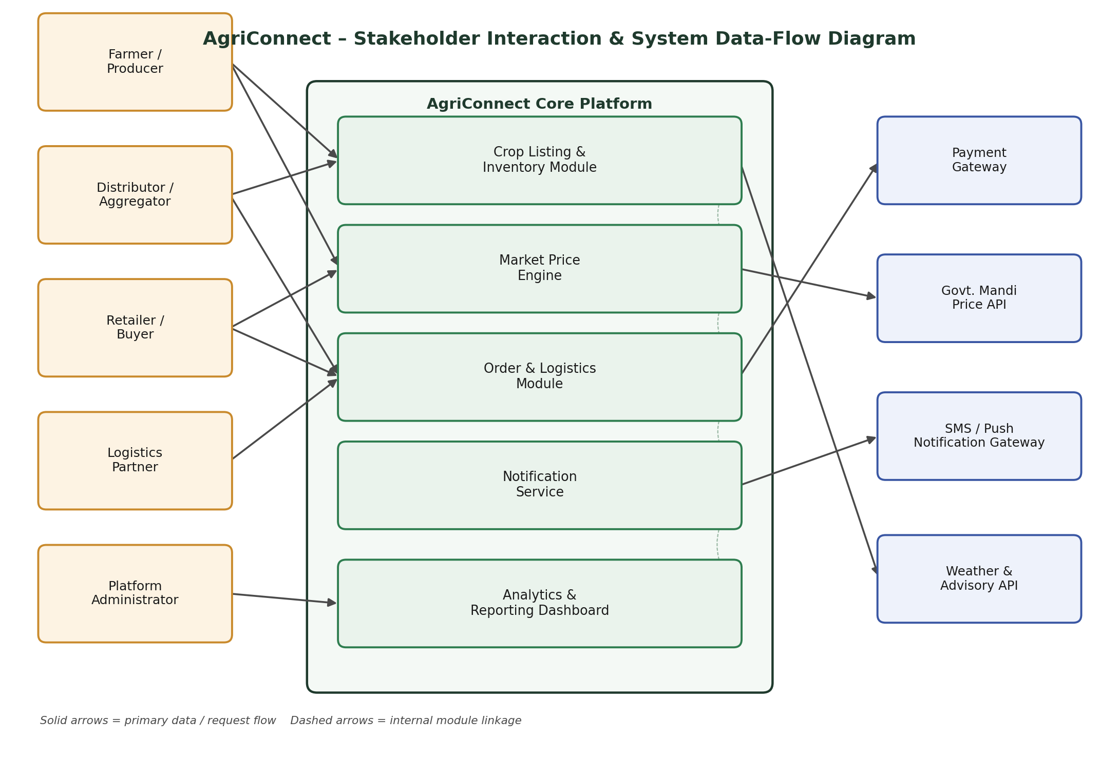
Figure 1: Stakeholder interaction and system data-flow diagram for AgriConnect.

8. Use Case Diagram
The use case diagram below consolidates the primary interactions identified in Section 4 into a single visual model, grouped by actor. The «include» relationships indicate use cases that are always triggered as part of another use case — for example, receiving an alert is included whenever an order is placed, and report generation is included as part of user and catalogue management.
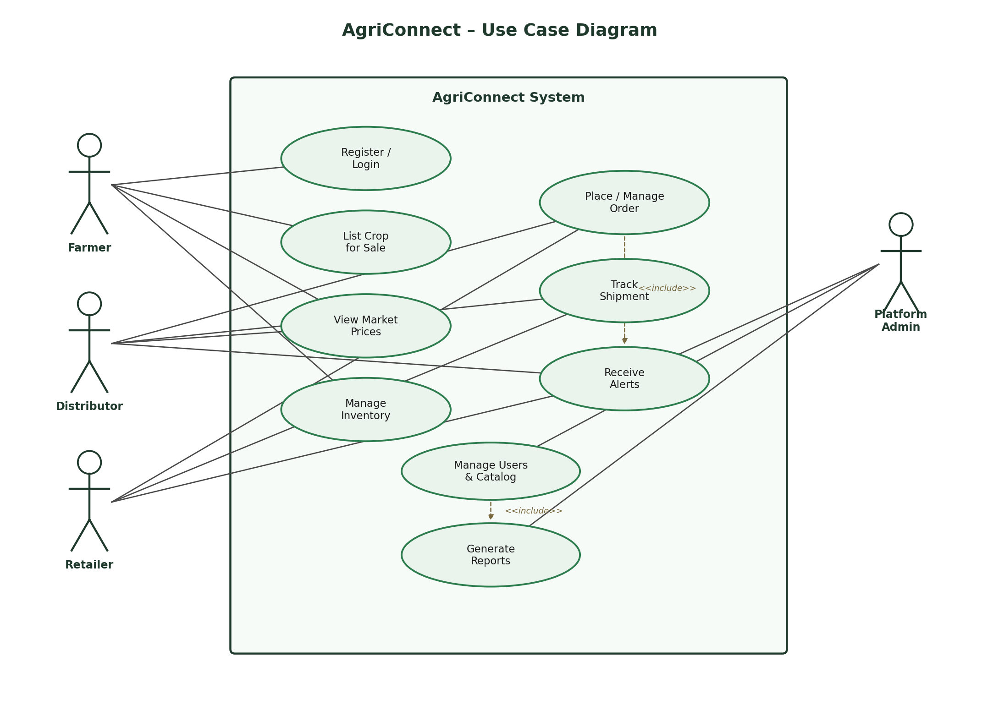
Figure 2: Use case diagram showing Farmer, Distributor, Retailer, and Platform Admin interactions.

9. UI Mock-ups
Three low-fidelity wireframes were produced to validate the core farmer-facing flows described in the use cases above: the home/dashboard screen, the crop listing form, and the order/shipment tracking screen. These wireframes are intentionally low-fidelity at this stage; visual design and detailed UI specification will be addressed during the design phase of the project.
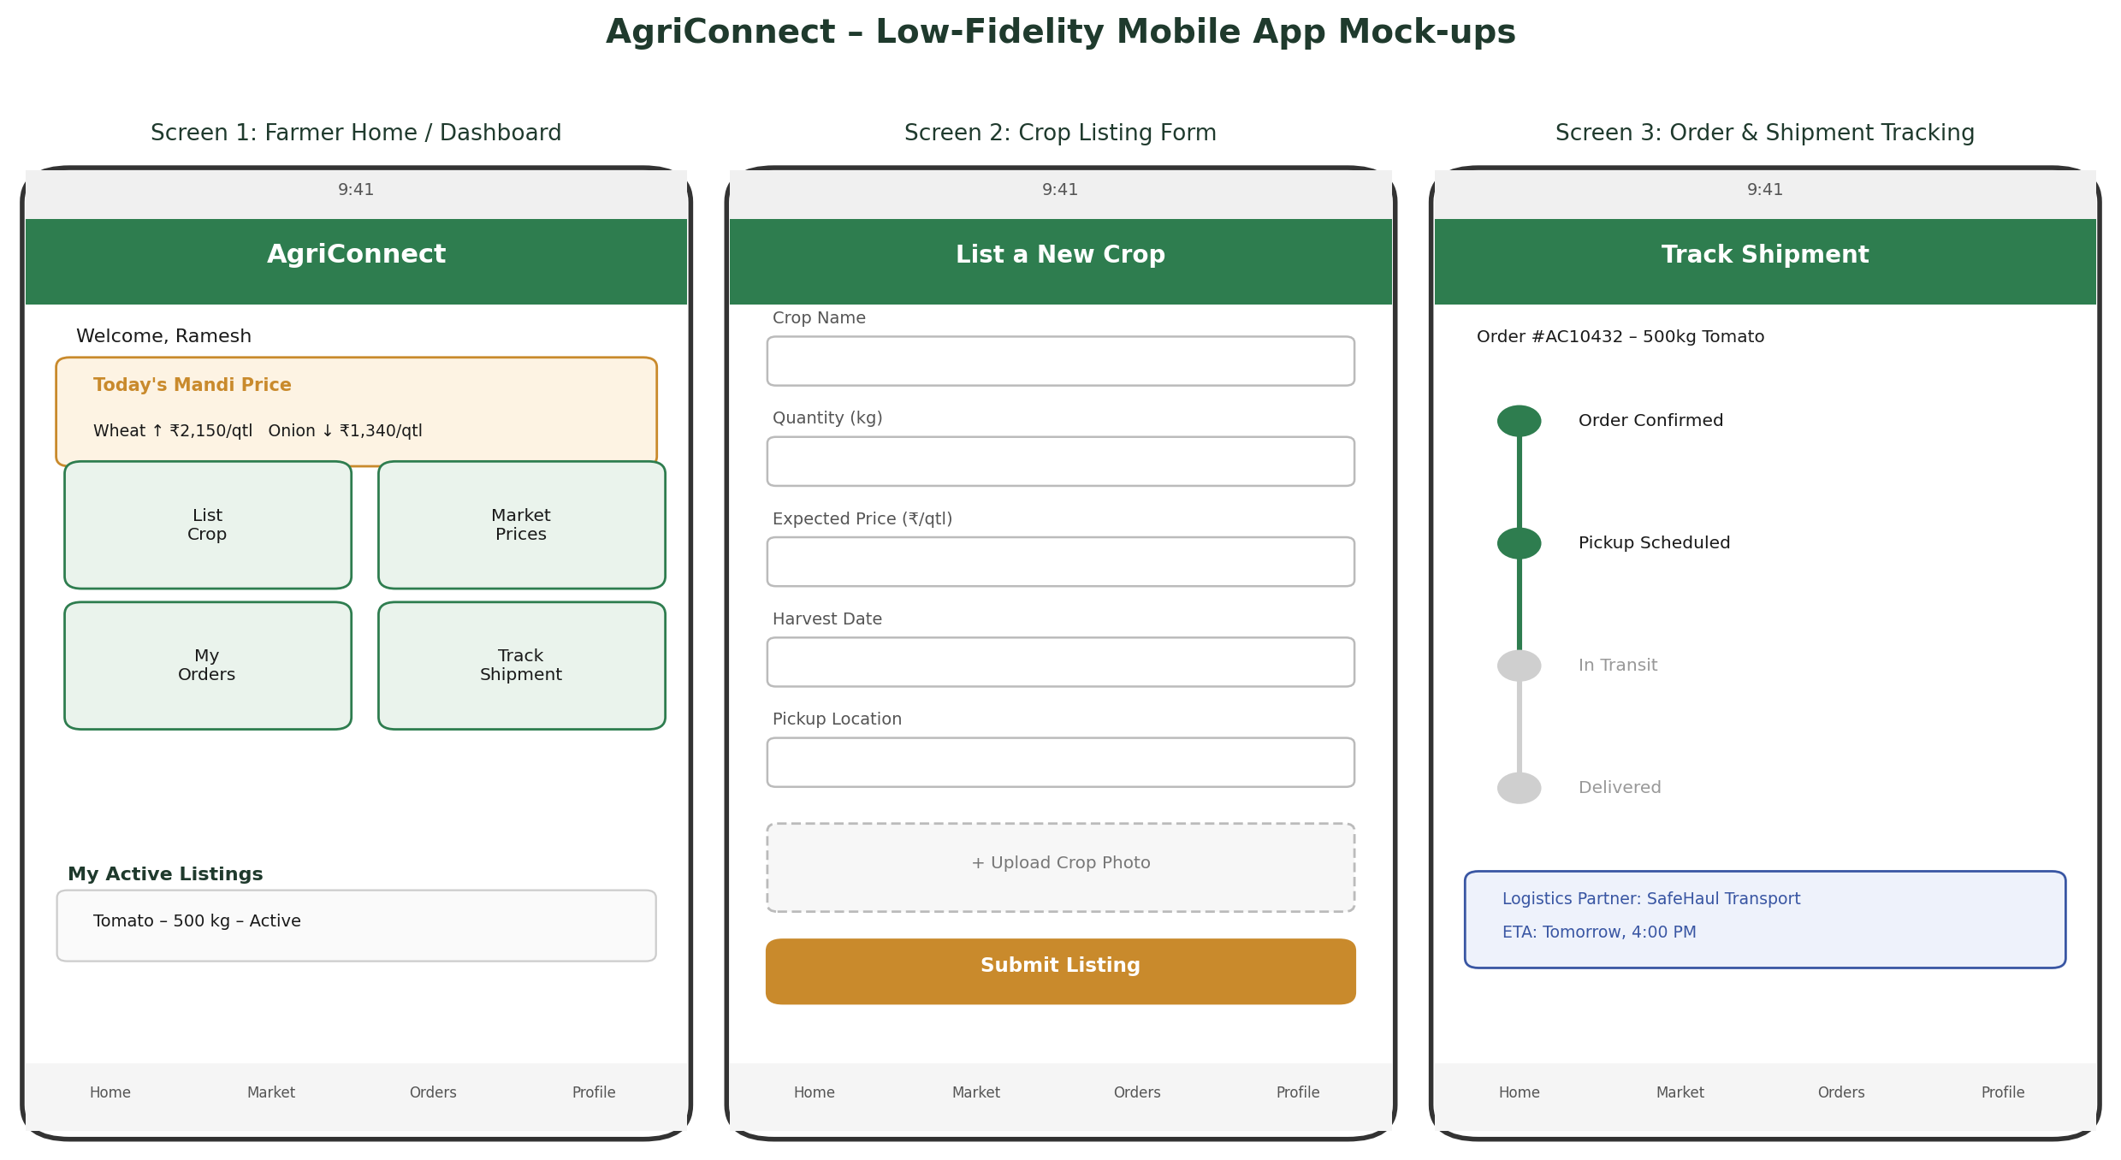
Figure 3: Low-fidelity mobile app mock-ups – Home Dashboard, Crop Listing Form, and Shipment Tracking.

Mock-up Walkthrough
- Screen 1 – Farmer Home/Dashboard: surfaces today's mandi price at a glance, quick actions for the four most common tasks, and a summary of the farmer's active listings (supports FR-6, FR-8, FR-11).
- Screen 2 – Crop Listing Form: a simple, linear form capturing crop name, quantity, expected price, harvest date, pickup location, and an optional photo, designed for low-literacy and low-bandwidth use (supports FR-6, NFR-5).
- Screen 3 – Order & Shipment Tracking: a step-based progress indicator communicates shipment status without requiring the user to interpret raw data (supports FR-18, US-6).

10. Assumptions & Constraints

10.1 Assumptions
- Target farmers have access to at least an entry-level Android smartphone, even if internet connectivity is intermittent.
- A government or third-party mandi price API is available for integration; where unavailable for a given region, manual price entry by an administrator will serve as a fallback data source.
- Logistics partners are onboarded as verified platform users rather than sourced through a fully open, unmoderated marketplace of carriers.
- Users have access to a valid mobile number for OTP-based verification and notifications.

10.2 Constraints
- The initial launch will target a single state or region to allow focused onboarding, localisation, and support.
- Payment gateway integration will initially support UPI and major digital wallets, with cash-on-delivery retained as a fallback option.
- Development timeline and resourcing for subsequent phases are bounded by the five-week internship schedule, requiring a phased (MoSCoW-prioritised) approach to implementation.

11. Requirements Traceability Matrix
The matrix below maps each user story to the functional requirement(s) that satisfy it, providing a basic traceability check to confirm that no user story is left unaddressed by the requirements catalogue in Section 5.
User Story | Related Functional Requirement(s)
US-1 | FR-6, FR-7
US-2 | FR-11, FR-12
US-3 | FR-21
US-4 | FR-8
US-5 | FR-15, FR-16, FR-20
US-6 | FR-18, FR-21
US-7 | FR-10
US-8 | FR-17, FR-18
US-9 | FR-3
US-10 | FR-24, FR-26
US-11 | FR-23
US-12 | FR-2, FR-4, FR-5

12. Conclusion
This report has documented a structured requirements gathering and analysis process for AgriConnect, an agribusiness solution intended to connect farmers, distributors, retailers, logistics partners, and platform administrators around a shared marketplace and advisory platform. Stakeholder identification and secondary research into sector-wide challenges — principally price information asymmetry, fragmented supply chains, logistics constraints, and low digital literacy — directly shaped the twelve user stories, four detailed use cases, twenty-seven functional requirements, and twelve non-functional requirements captured above.
The accompanying data-flow diagram, use case diagram, and low-fidelity mock-ups provide a shared visual reference that should reduce ambiguity during the design and development phases that follow. Taken together, these artefacts give a defensible basis for the Week 2 System Architecture and Design task, in which the modules identified here — Crop Listing & Inventory, Market Price Engine, Order & Logistics, Notification Service, and Analytics & Reporting — will be translated into a concrete technical architecture.

